# LUMIERE AI: THE FUTURE OF VIDEO CREATION

A SEMINAR REPORT

Submitted by

## FAHAD C JAMAL

### REG.NO: MCK22MCA-2016

to

the APJ Abdul Kalam Technological University

in partial fulfilment of the requirement for the award of the Degree of

*Master of Computer Applications*



**Department of Computer Applications** Musaliar College of Engineering & Technology Pathanamthitta, Kerala

DECEMBER 2023

# DECLARATION

I undersigned hereby declare that the project report **“Online Movie Ticket Booking System”** submitted for partial fulfillment of the requirements for the award of degree of Master of Computer Application of the APJ Abdul Kalam Technological University, Kerala is a bona-fide work done by me under supervision of **Prof. Sanooja Beegam (Assistant Professor).** This submission represents my ideas in my own words and where ideas or words of others have been included; I have adequately and accurately cited and referenced the original sources. I also declare that I have adhered to ethics of academic honesty and integrity and have not misrepresented or fabricated any data or idea or fact or source in my submission. I understand that any violation of the above will be a cause for disciplinary action by the institute and/or the University and can also evoke penal action from the sources which have thus not been properly cited or from whom proper permission has not been obtained.

### FAHAD C JAMAL

Place: Date:

**DEPARTMENT OF COMPUTER APPLICATIONS MUSALIAR COLLEGE OF ENGINEERING & TECHNOLOGY**

**PATHANAMTHITTA, KERALA-689645**



# CERTIFICATE

This is to certify that the report entitled “**Online Movie Ticket Booking System**” submitted by **FAHAD C JAMAL (Register No: MCK22MCA-2016)**, to the APJ Abdul Kalam Technological University in partial fulfillment of requirement for the award of Degree of Master of Computer Application is a bona-fide record of the project work carried out by him, under our guidance and supervision. This report in any form has not been submitted to any other University or Institute for any purpose.

Guide Project Coordinator

## Prof Sanooja Beegam Prof Jogimol Joseph

**Assistant Professor Assistant Professor**

## Dept. of Computer Applications Dept. of Computer Applications

Head of the Department **Prof Shyma Kareem Assistant Professor**

**Dept. of Computer Applications**

# CONTENTS

|  |  |  |  |  |
| --- | --- | --- | --- | --- |
| **CONTENTS** |  |  |  | **PAGE NO** |
| **ACKNOWLEDGEMENT** | | |  | **vi** |
| **ABSTRACT** |  |  |  | **1** |
| **CHAPTER 1** | **INTRODUCTION** | | | **2** |
|  | 1.1 | General Background | | 2 |
|  | 1.2 | Objective | | 2 |
|  | 1.3 | Scope of the Project | | 2 |
|  | 1.4 | Existing System | | 3 |
|  | 1.5 | Proposed System | | 3 |
| **CHAPTER 2** | **LITERATURE REVIEW** | | | 4 |
| **CHAPTER 3** | **SYSTEM REQUIREMENTS AND SPECIFICATIONS** | | | **6** |
|  | 3.1 | Proposed Methodology | | 6 |
|  | 3.2 | Technical requirements of the System | | 6 |
|  |  | 3.2.1 | Software Requirements | 6 |
|  |  | 3.2.2 | Hardware Requirements | 6 |
|  | 3.3 | Development Tools | | 6 |
|  | 3.4 | Module Description | | 8 |
|  | 3.5 | Feasibility Study | | 9 |
|  | 3.6  3.7 | System Design  Tables Used | | 10  11 |
|  | 3.8 | Process Design | | 15 |
|  |  | 3.8.1  3.8.2 | Data Flow Diagram  Usecase Diagram | 15  18 |
| **CHAPTER 4** | **SYSTEM ARCHITECTURE** | | | **19** |
|  | 4.1 | Implementation | | 19 |
|  | 4.2 | System Testing | | 21 |
|  | 4.3 | Comparison and Results | | 21 |
| **CHAPTER 5** | **CONCLUSION** | | | **23** |
|  | 5.1 | Scope For Future Work | | 23 |
|  | 5.2 | Reference | | 24 |
|  | **APPENDIX** | |  | 25 |

## LIST OF TABLES

|  |  |  |
| --- | --- | --- |
| No. | Title | PageNo. |
| 1 | Login | 11 |
| 2 | Registration | 11 |
| 3 | Bookings | 12 |
| 4 | Contacts | 12 |
| 5 | Movies | 13 |
| 6 | News | 13 |
| 7 | Screens | 14 |
| 8 | Shows | 14 |
| 9 | Showtimes | 14 |
| 10 | Theatre | 15 |

# 

**LIST OF FIGURES**

|  |  |  |
| --- | --- | --- |
| **Figures** | **Title** | **Page No.** |
| Figure 1 | DFD Level 0 | 16 |
| Figure 2 | DFD Level 1 | 16 |
| Figure 3 | Usecase Diagram | 18 |
| Figure 4 | System Architecture | 19 |

# 

# ACKNOWLEDGEMENT

I am also thankful to **Prof SHYMA KAREEM** (**Assistant Professor**), Head of the Department, Department of Computer Applications, Musaliar College of Engineering and Technology, for her advice and help extended to me during the course.

I like to express my deep gratitude and sincere thanks to **Prof SANOOJA BEEGAM (Assistant Professor)**, Department of Computer Science and Engineering, Musaliar College of Engineering and Technology, for her valuable and constructive encouragement and suggestions. Under her guidance and supervision, this work came into reality.

I like to express my deep gratitude and sincere thanks to Project Coordinator **Prof JOGIMOL JOSEPH (Assistant Professor)**, Department of Computer Applications, Musaliar College of Engineering and Technology, for her advice and help extended to me during the course.

I also express my deep sense of gratitude to all the faculty members, Department of Computer Applications, Musaliar College of Engineering and Technology, without whom this work would have been a distant reality.

Finally, I would also wish to record my gratefulness to our family, friends, and classmates for their help, support, and valuable prayers for completing this work successfully. Above all, I like to thank God Almighty for his bountiful blessings for the successful completion of this work.

**FAHAD C JAMAL**

# ABSTRACT

The "Online Movie Ticket Booking System" represents a groundbreaking project at the forefront of the digital entertainment landscape, integrating cutting-edge technologies to revolutionize the movie ticket reservation experience. This project embraces the dynamic nature of e-commerce trends, leveraging advancements in technology, user preferences, and innovative business strategies to create a platform that transcends traditional ticket booking paradigms.

At its core, the project prioritizes user experience, drawing inspiration from established principles and practical considerations. The aim is to deliver an interface that is not only functional but intuitively navigable, ensuring a seamless and enjoyable journey for users engaging with the online movie ticket booking system.

Security is a paramount concern in the era of online transactions, and this project addresses it comprehensively. Robust encryption protocols, state-of-the-art authentication methods, and stringent data protection measures are integrated to fortify user information, instilling trust and confidence in the security of the online platform.

Recognizing the ubiquity of mobile technology, the project incorporates a mobile-first approach, drawing insights from user preferences and challenges outlined by Maria S. Rodriguez. The mobile interface is designed to enhance accessibility, convenience, and overall user engagement, catering to the preferences of a diverse and mobile-savvy audience.

Furthermore, the project embraces the power of big data analytics, as championed by Michael K. Thompson. Leveraging vast datasets, the platform employs analytics to discern patterns in user behavior, preferences, and trends. This data-driven approach empowers the system to adapt dynamically, offering personalized recommendations, targeted marketing strategies, and an optimized overall experience for users.

**CHAPTER 1**

**INTRODUCTION**

The Online Movie Ticket Booking System is a groundbreaking concept that has the potential to revolutionize the conventional movie ticketing process in this age of rapid technological innovation and growing digitization. With an emphasis on accessibility and simplicity, this initiative seeks to transform the way that moviegoers interact with the cinematic experience as entertainment fans increasingly gravitate to leading digital platforms. The ability to browse, choose, and purchase movie tickets with never-before-seen convenience will be provided to users via a smooth and user-friendly web interface.

1. **GENERAL BACKGROUND**

The entertainment sector, namely the movie industry, has undergone a paradigm change recently. A digital revolution is replacing the old way of buying movie tickets at actual counters, providing viewers with unmatched ease. In light of this change, this initiative is born, fitting in with both the changing demands of theatre managers and owners and the modern tastes of patrons.

1. **OBJECTIVE**

The main goal of the Online Movie Ticket Booking System is to completely transform the way that movie tickets are purchased by creating a digital platform that is easy to use, secure, and guarantees quick and easy transactions. The initiative aims to give consumers an easy-to-use interface that makes it simple for them to explore forthcoming films, choose their favorite showtimes, and purchase tickets. Advanced capabilities to manage movie listings, show schedules, and venue details will be helpful to theatre owners and administrators. These tools will also make it easier to add new theatres and movies to the system. Theatre owners may monitor today's shows, bookings, and seat availability with the system's emphasis on real-time information. Users can receive quick updates on seat availability, show schedules, and booking confirmations.

1. **SCOPE OF THE PROJECT**

The whole movie ticket booking procedure, from user registration and movie research to booking confirmation and safe payments, is covered by the Online Movie Ticket Booking System. The project also includes cinema administration, giving administrators effective control over show scheduling, movie lists, and facility specifics.

1. **EXISTING SYSTEM**

The current state of movie ticket booking is typified by conventional techniques that involve real ticket counters and, occasionally, uncomplicated internet booking services. These systems frequently lack the sophistication needed to live up to the expectations of contemporary theatre owners and patrons, which results in inefficient booking procedures and restricted access to real-time data.

1. **PROPOSED SYSTEM**

By providing a thorough digital platform, the suggested Online Movie Ticket Booking System aims to solve the flaws in the current setup. Users' interactions with the moviegoing experience will be redefined by this system's improved user interface, effective theatre management tools, and secure transaction capabilities. In order to meet the growing demand for seamless, digital solutions in the entertainment business, the project intends to close the gap between traditional ticketing systems.

**CHAPTER 2**

**LITERATURE REVIEW**

To establish a foundation for the project, the following published articles have been consulted. The following papers have been cited: -

1. **John A. Smith**, “**Emerging Trends in E-Commerce for Entertainment Services**”, International Conference on E-Commerce Innovations, November 2020.

Smith's groundbreaking research offers a thorough examination of the dynamic changes and new developments in the field of e-commerce, with an emphasis on how these developments affect online movie ticket purchasing platforms. Smith reveals the changing environment that has been influenced by technological breakthroughs, shifts in consumer behavior, and creative corporate tactics through painstaking investigation. The review is an invaluable tool for comprehending how these trends affect the layout, operation, and interaction of users on websites that are devoted to booking movie tickets. Smith's observations provide a forward-looking viewpoint that is crucial for every developer or stakeholder, from the incorporation of augmented reality to the emergence of personalized recommendation algorithms.

1. **Emily R. Johnson**, “**User Experience in Online Ticket Booking Systems**”, Human-Computer Interaction Symposium, September 2018.

In-depth analysis of user experience (UX) design that is geared towards the online movie ticket booking space can be found in Johnson's thorough evaluation. Going beyond the fundamentals of user experience, Johnson carefully examines the particular difficulties and possibilities involved in creating user interfaces that satisfy the wide range of demands of moviegoers. The study looks at how visual components function, how subtle navigation is, and how intuitive design affects the user experience as a whole. Johnson's observations go beyond theory to provide developers with useful advice on how to improve the usability and user pleasure of their online platforms. For anyone devoted to providing a flawless service, this evaluation serves as a fundamental manual.

1. "**Protective Measures for Online Movie Ticket Purchases**," Cybersecurity Conference, June 2019– **Williams, David L**.

Williams carefully examines security procedures in order to address a crucial feature of online movie ticket ordering systems. This review offers a thorough summary of the most recent developments in protecting user data and financial transactions in the context of cinema ticket reservations in a time when data breaches and cyber threats are major concerns. Williams examines best practices, authentication techniques, and encryption systems to guarantee the integrity and security of user data. With the growing popularity of online transactions, this review turns into a vital tool for developers, system architects, and other stakeholders trying to build reliable online movie ticketing platforms.

1. "**Usage of Mobile Apps in Movie Ticket Booking Platforms**," October 2019; Mobile Technology Forum, **Maria S. Rodriguez**

In his perceptive analysis, Rodriguez emphasizes how mobile apps are revolutionizing the movie ticket booking industry. In an era where smartphones are commonplace, this study examines user preferences, obstacles, and the general effect of mobile platforms on the ease of use and accessibility of online movie ticket reservations. In this context, Rodriguez explores the special qualities of mobile apps that make them successful, including topics like fluid payment integrations, real-time notifications, and flexible user interfaces. To optimize the entire user experience and engagement levels in mobile applications, developers and business strategists can utilize the review as a strategic guide.

1. Data Science and Analytics Conference, "**Big Data Analytics in Online Movie Ticket Booking Systems**," March 2022– **Thompson, Michael K.**

In his ground-breaking review, Thompson examines how big data analytics can be applied to online movie ticket booking platforms to create revolutionary change. Through the examination of extensive datasets, Thompson deciphers patterns in user behavior, inclinations, and tendencies, offering vital perspectives for enhancing the efficacy and efficiency of these digital channels. The review explores the practical applications of data analytics, including targeted marketing campaigns, dynamic pricing models, and personalized suggestions, in addition to its technical components. Thompson's study is a key resource for stakeholders hoping to use big data to transform the online movie ticket industry in an era where data-driven decision-making is crucial.

**CHAPTER 3**

**SYSTEM REQUIREMENTS AND SPECIFICATIONS**

1. **PROPOSED METHODOLOGY**

The online movie ticket booking system's methodology is based on a methodical approach to fulfilling user requirements and guaranteeing a smooth experience. It starts with a thorough analysis of user needs, and the system design includes the architecture, database structure, and module definitions. The database design optimizes the storage of important data, and the user interface design prioritizes usability and responsiveness. The ticket booking workflow incorporates seat selection, secure payment processing, and confirmation mechanisms. Security is prioritized through user authentication and authorization, and real-time movie information is integrated through external APIs. Users are kept informed by a robust notification system, and extensive testing guarantees a bug-free experience.

1. **TECHNICAL REQUIREMENTS OF THE SYSTEM**
2. **SOFTWARE REQUIREMENTS**

|  |  |  |
| --- | --- | --- |
| Operating System | : | Windows 10 or above |
| Front end  Back end | :  : | HTML, CSS, JavaScript  MySQL |
| Software Used  Web Browser | :  : | VSCode  Internet Explorer/Google Chrome/Firefox |

1. **HARDWARE REQUIREMENTS**

|  |  |  |
| --- | --- | --- |
| Processor | : | Minimum 1 GHz |
| RAM | : | 4GB or above |
| Storage | : | Less than 100MB |

1. **DEVELOPMENT TOOLS**

**HTML**

The standard markup language used to build web pages is called Hypertext Markup Language, or HTML for short. HTML is a fundamental technology used to generate web pages and user interfaces for mobile and web applications, together with CSS and JavaScript. HTML files can be read by web browsers and converted into visual or aural web pages. HTML is a markup language, not a programming language; it explains a website's structure semantically and provides presentational clues.

HTML allows programs written in languages like JavaScript to be embedded, which changes how HTML pages behave. Cascading Style Sheets (CSS) are another resource that HTML markup can use to tell the browser how to format and style text and other content.

Cascading Style Sheets (CSS) are another tool that web browsers can use to specify how text and other content should look and be laid out. CSS is preferred by the W3C over explicit display HTML markup.

**SQL DATABASE**

Microsoft created the relational database management system known as Microsoft SQL Server. It is a software product known as a database server, and its main job is to store and retrieve data when other software applications ask for it. These apps can run on the same computer or on a different machine connected to a network, including the Internet. With a variety of target audiences and workloads in mind, Microsoft offers at least a dozen various editions of Microsoft SQL Server, spanning from modest, single-machine apps to massive, multi-user Internet-facing applications.

Programming's domain-specific language, Structured Query Language (SQL), is intended for stream processing in relational data stream management systems (RDSMS) or database management systems (RDBMS).

SQL is made up of three languages: data description, data manipulation, and data control. It was initially based on relational algebra and tuple relational calculus. Data access control, schema construction and change, data insert, query, update, and deletion are all included in SQL's scope. SQL contains procedural features as well as declarative language aspects, even though it is typically referred to as such (4GL).

**PHP**

The dynamic scripting language PHP, or Hypertext Preprocessor, is frequently used for server-side web development. Its syntax, which ends statements with semicolons, enables it to be used as a standalone script or embedded into HTML. Variables have loose typing and begin with the dollar sign ($). Integers, floats, strings, booleans, arrays, and objects are examples of data types. Arithmetic, comparison, and logical operators are examples of operators. Looping structures (for, while, do-while foreach) and conditional statements (if, else, elseif) are features of control structures. Value and reference parameter passing are two methods that functions that are defined with the 'function' keyword can use. The class keyword in PHP allows classes to be declared, which facilitates object-oriented programming. Configuration directives and exception handling (try, catch, throw) are part of error handling. Reading and writing files is handled by handling functions (fopen, fread, fwrite, fclose), and database connectivity is provided via extensions (e.g., MySQL, PostgreSQL). Validating user input and filtering input data are examples of security methods. PHP's ability to integrate with HTML allows web servers to generate dynamic content, and the PHP manual available at php.net is an extensive source of information and examples.

1. **MODULE DESCRIPTION**

The project "Online Movie Ticket Booking System" likely includes the following modules:

**ADMIN**

The Admin Module enables safe authentication and authorization for administrators, allowing them to manage cinemas by adding new ones, update upcoming movie news, oversee user accounts, and modify system settings to preserve operational efficiency.

**USER**

Users can browse upcoming movie news, explore movie listings, view detailed movie information including trailers and ratings, choose showtimes, select how many seats they want, and manage their booking history through an easy-to-use profile management system thanks to the User Module, which also makes user registration and authentication easier.

**THEATRE**

A wide range of features are available with the Theatre Module, such as a home dashboard that shows the shows and reservations for the current day, the capacity to add new movies with descriptions and trailers, browse the current movie listings, add showtimes, keep track of the shows and reservations for the current day, access comprehensive show information, and offer theatre details on a dedicated page.

**MOVIE**

The Movie Module is designed to manage movie information efficiently. It allows you to classify movies by language and genre, gather reviews and ratings, upload and show trailers, and update content dynamically for a fun user experience.

**BOOKING**

The Booking Module gives users the option to choose and reserve seats, get real-time seat availability updates, validate reservations by generating e-tickets, and easily link these reservations with their user profiles. It also sends out timely email or SMS notifications.

**PAYMENT**

The Payment Module includes a safe payment gateway that accepts a variety of payment methods, including debit cards, credit cards, and online wallets. It also keeps track of transactions, generates receipts, processes refunds and cancellations, and protects user data with strong encryption.

1. **FEASIBILITY STUDY**

Testing a system's feasibility involves determining if it can efficiently employ resources and satisfy user expectations. The technical and financial viability of the system to be constructed is the primary objective of a feasibility study. This is accomplished by looking at current systems in the field of study and coming up with concepts for brand-new systems. A feasibility study could be appended to the system specification as an annex and published as a distinct report to higher-ups. There are several connections between risk analysis and feasibility. You are less likely to generate high-quality software the riskier your project is.

There are three aspects in the feasibility study portion of the preliminary investigation.

1. **Technical Feasibility**

The system's technical viability for the organization is determined by its technological feasibility. Technically speaking, the designed system is doable and simple to integrate with. It is essential that the technical feasibility assessment be completed concurrently with the analysis and definition process. It can identify a computer system and expand it to accommodate the suggested system. A technical feasibility evaluation looks at the requirements for both software and hardware. The project's scope included determining if work would be completed on the present machinery and whether a feasibility assessment would need to consider currently available software. The outcomes were favorable.

1. **Economic Feasibility**

Cost and benefit analysis is a frequent term for economic analysis. For the majority of the system, economic rationale serves as the fundamental factor. The cost of developing a new system is one of the aspects that affects that process. The suggested system was created using the resources at hand. The software always produces a profit because the cost of input is nearly zero. Software that is financially feasible is so available. In the existing system, labor is more in demand.

1. **Operational Feasibility**

The suggested system's performance during installation is determined by its operational viability. The suggested system outperforms the current one in this instance. For this reason, the system is seen as up. If an existing system is easily understood by users, it is deemed operational. User acceptability is the biggest issue while creating a new system. The organization's operational needs should be satisfied by the suggested system. In short, this proof of concept investigates whether the system will function after it is developed and implemented. Exist significant obstacles to implementation? The following queries will assist in determining whether your proposal is operationally feasible. Is the project receiving enough administrative support?

1. **SYSTEM DESIGN**
2. **INPUT DESIGN**

The Online Movie Ticket Booking System collects personal information from users via registration forms, including name, email address, password, and contact data. A smooth booking process is further enhanced by user preferences for movie searches, seat choices, and payment details. To provide effective system management, administrators enter theatre information, movie uploads, showtime setups, and real-time monitoring.

1. **OUTPUT DESIGN**

On the output side, the system creates user profiles, keeps a thorough booking history, and produces booking confirmations with movie data. Real-time overviews of shows and bookings, a movie management interface for new and upcoming releases, and theatre dashboards presenting show and booking statistics are all beneficial to administrators. To keep viewers updated, the system also offers dynamic content updates for films, including reviews and ratings. The output design is completed with transaction confirmations, receipt creation, and refund alerts, guaranteeing a clear and convenient movie ticket booking process.

1. **DATABASE DESIGN**

The design of data storage is one of the most significant jobs performed during the design process. A database is an arrangement of linked data that is kept as redundantly as possible to provide rapid and effective service to a large number of consumers. The main goal is to provide users with convenient, rapid, affordable, and flexible access. The data terms are kept in relation to one another. Normalization is done to have the least amount of redundancy and maximum stability as well as to obtain internal consistency of data. This guarantee reducing the amount of data that needs to be stored, reducing the possibility of inconsistent data, and optimizing for updates. The users of the system can see that. The creation of a database is the main goal, and data is treated as original resources.

1. **TABLES USED**

**Table Name: tbl_login**

**Description: Contains login details.**

|  |  |  |  |
| --- | --- | --- | --- |
| **Fields** | **Data Types** | **Constraints** | **Description** |
| id | Integer | Primary key | To specify id |
| user_id | Integer | Foreign key | To specify user id |
| username | Varchar | Not null | To specify username |
| password | Varchar | Not null | To specify password |
| user_type | Integer | Not null | To specify type |

**Table Name: tbl_registration**

**Description: Contains registration details.**

|  |  |  |  |
| --- | --- | --- | --- |
| **Fields** | **Data Types** | **Constraints** | **Description** |
| user_id | Integer | Primary key | To specify user id |
| name | Varchar | Not null | To specify name |
| email | Varchar | Not null | To specify email |
| phone | Varchar | Not null | To specify phone number |
| age | Integer | Not null | To specify age |
| gender | Varchar | Not null | To specify gender |

**Table Name: tbl_bookings**

**Description: Contains booking details.**

|  |  |  |  |
| --- | --- | --- | --- |
| **Fields** | **Data Types** | **Constraints** | **Description** |
| book_id | Integer | Primary key | To specify book id |
| ticket_id | Varchar | Foreign key | To specify ticket id |
| t_id | Integer | Foreign key | To specify theatre id |
| user_id | Integer | Foreign key | To specify user |
| show_id | Integer | Foreign key | To specify show id |
| screen_id | Integer | Foreign key | To specify screen id |
| no_seats | Integer | Not null | To specify seats |
| amount | Integer | Not null | To specify amount |
| ticket_date | Date | Not null | To specify ticket date |
| date | Date | Not null | To specify date |
| status | Integer | Not null | To specify status |

**Table Name: tbl_contact**

**Description: Contains contact details.**

|  |  |  |  |
| --- | --- | --- | --- |
| **Fields** | **Data Types** | **Constraints** | **Description** |
| contact_id | Integer | Primary key | To specify contact |
| name | Varchar | Not null | To specify name |
| email | Varchar | Not null | To specify email |
| mobile | Integer | Not null | To specify mobile number |
| subject | Varchar | Not null | To specify subject |

**Table Name: tbl_movie**

**Description: Contains movie details.**

|  |  |  |  |
| --- | --- | --- | --- |
| **Fields** | **Data Types** | **Constraints** | **Description** |
| movie_id | Integer | Primary eky | To specify movie |
| t_id | Integer | Foreign key | To specify theatre |
| movie_name | varchar | Not null | To specify movie name |
| cast | Varchar | Not null | To specify cast |
| desc | Varchar | Not null | To specify description |
| release_date | Date | Not null | To specify release date |
| image | Varchar | Not null | To specify image |
| video_url | Varchar | Not null | To specify trailer |
| status | Integer | Not null | To specify status |

**Table Name: tbl_news**

**Description: Contains upcoming movie details.**

|  |  |  |  |
| --- | --- | --- | --- |
| **Fields** | **Data Types** | **Constraints** | **Description** |
| news_id | Integer | Primary key | To specify movie news |
| name | Varchar | Not null | To specify movie name |
| cast | Varchar | Not null | To specify cast |
| news_date | Date | Not null | To specify news date |
| description | Varchar | Not null | To specify description |
| attachment | Varchar | Not null | To specify attachment |

**Table Name: tbl_screens**

**Description: Contains screen details.**

|  |  |  |  |
| --- | --- | --- | --- |
| **Fields** | **Data Types** | **Constraints** | **Description** |
| screen_id | Integer | Primary key | To specify screen id |
| t_id | Integer | Foreign key | To specify theatre id |
| screen_name | Varchar | Not null | To specify screen name |
| seats | Integer | Not null | To specify seats |
| charge | Integer | Not null | To specify charge |

**Table Name: tbl_shows**

**Description: Contains show details.**

|  |  |  |  |
| --- | --- | --- | --- |
| **Fields** | **Data Types** | **Constraints** | **Description** |
| s_id | Integer | Primary key | To specify show id |
| st_id | Integer | Foreign key | To specify showtime id |
| theatre_id | Integer | Foreign key | To specify theatre id |
| movie_id | Integer | Foreign key | To specify movie id |
| start_date | Date | Not null | To specify start date |
| status | Integer | Not null | To specify status |

**Table Name: tbl_show_time**

**Description: Contains showtime details.**

|  |  |  |  |
| --- | --- | --- | --- |
| **Fields** | **Data Types** | **Constraints** | **Description** |
| st_id | Integer | Primary key | To specify show time id |
| screen_id | Integer | Foreign key | To specify screen id |
| name | Varchar | Not null | To specify name |
| start_time | Time | Not null | To specify start time |

**Table Name: tbl_theatre**

**Description: Contains theatre details.**

|  |  |  |  |
| --- | --- | --- | --- |
| **Fields** | **Data Types** | **Constraints** | **Description** |
| id | Integer | Primary key | To specify id |
| name | Varchar | Not null | To specify name |
| address | Varchar | Not null | To specify address |
| place | Varchar | Not null | To specify place |
| state | Varchar | Not null | To specify state |
| pin | Integer | Not null | To specify pin |

1. **PROCESS DESIGN**
2. **DATA FLOW DIAGRAM**

A data flow diagram (DFD) is a graphical representation of the 'flow’ of the data through an information system, modelling its process aspects. Often, they are preliminary step used to create an overview of the system which can later be elaborated.

A DFD shows what kind of information will be input to and output from the system, where the data will come from and go to, and where the data will be stored. It does not show information about the timing of processes, or information about whether processes will operate in sequence or in parallel.

Data Flow Diagram is a logical representation of the data flow of the project. Various symbols are used for drawing DFD. It has a source and destination. The process is represented using circles and source and destination using squares. The data flow is represented using circles and source and destination are represented using squares. The data flow is represented using arrows. One reader can easily get the idea about the project through Data Flow Diagram.

* Source rectangle, which defines or destination.
* Arrow, which shows dataflow.

* Circle, which represents a process that transforms incoming data into outgoing flow.
* Open rectangle, which shows a data storage.

**DFD Level 0:**

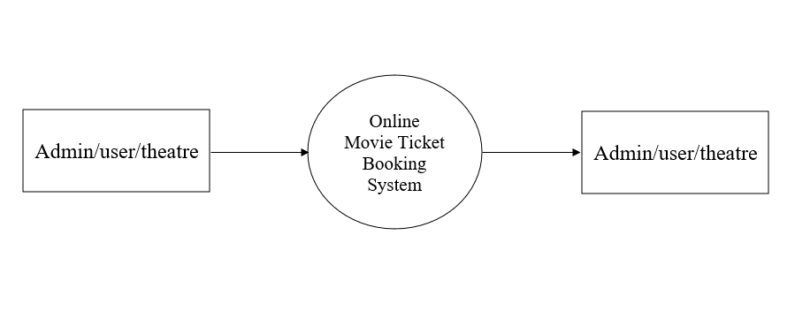

**DFD Level 1:**

Level 1 DFD for User Module

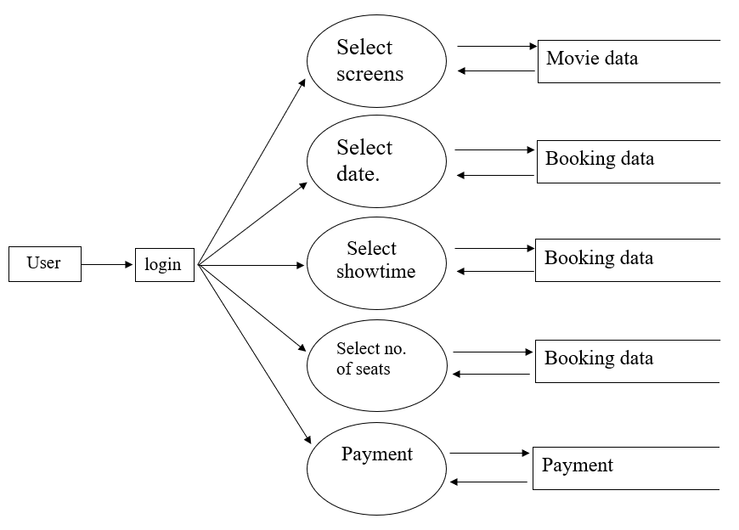

**DFD Level 1:**

Level 1 DFD for Admin Module

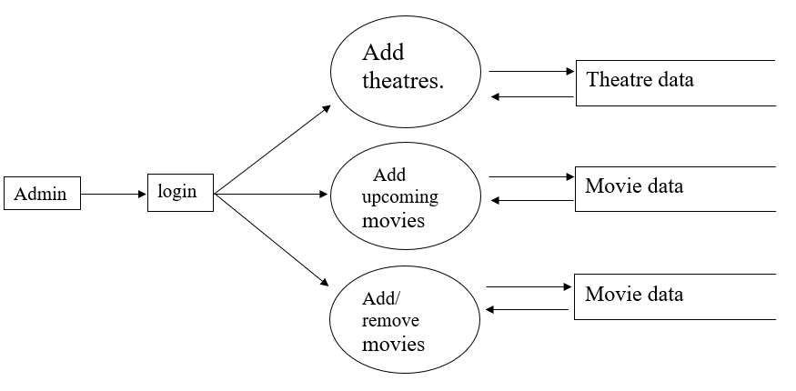

**DFD Level 1:**

Level 1 DFD for Theatre Module

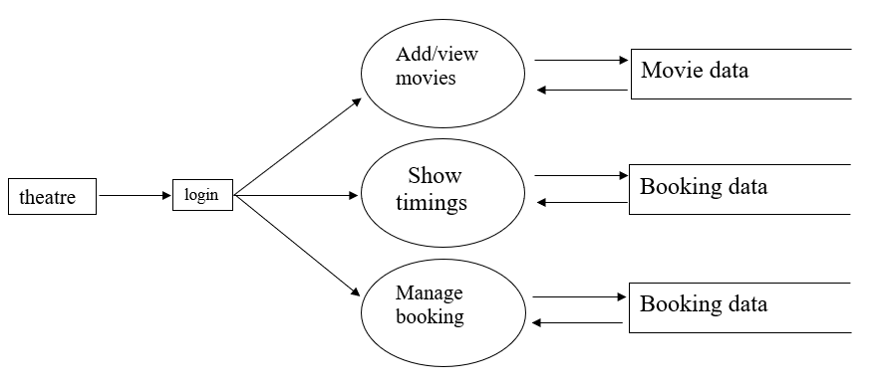

1. **USECASE DIAGRAM**

A user case is a set of scenarios that describing an interaction between a user and a system. The interaction between the actors and the use case is shown in a use case diagram. Use case and actors are the two primary elements of a use case diagram. An actor represents a user or another system that will interact with system that will interact with the system we are modeling. A use case is an external view of the system that represents some action the user might perform in order to complete a task. A use case diagram is used in almost in every project. They are helpful in exposing requirements and planning the project. During initial stage of a project most cases should be defined but as the project continues more might become visible.

##### Usecase Actor

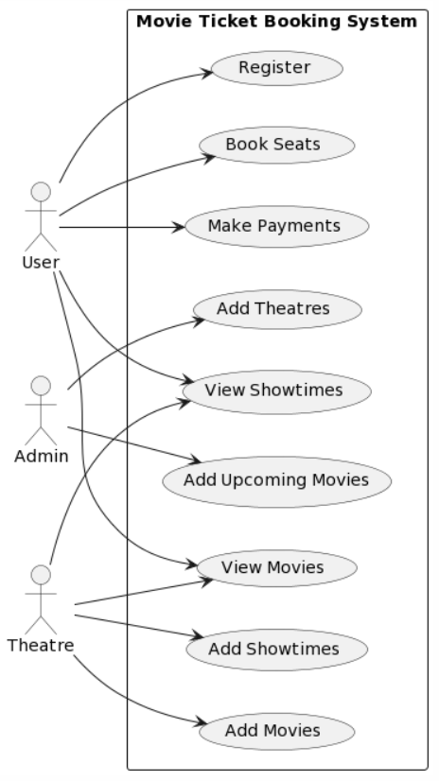

**CHAPTER 4**

**SYSTEM ARCHITECTURE**

The system architecture for the Online Movie Ticket Booking System comprises a frontend that includes user interfaces for various stakeholders. The backend consists of modular components: the User Module manages user-related tasks, the Admin Module oversees administrative functions, the Theatre Module handles theatre-specific operations, the Movie Module manages movie-related information, the Booking Module takes care of the booking process, and the Payment Module integrates secure payment gateways. The database stores and manages diverse data, while a Secure Payment Gateway ensures secure transactions. External APIs enhance the system's functionality by integrating with external services, such as movie databases, for real-time updates. This architecture ensures a cohesive, scalable, and efficient implementation of the entire online movie ticket booking process.

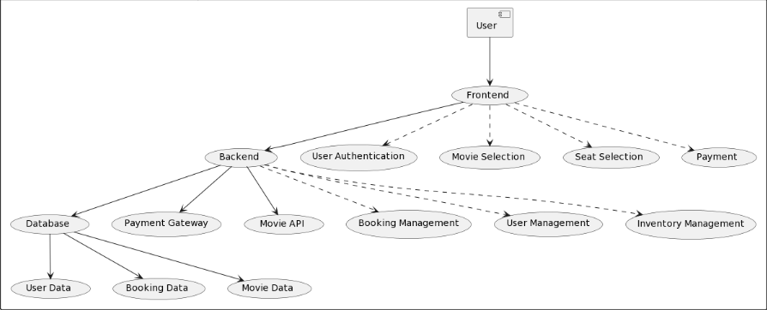

**4.1 IMPLEMENTATION**

**4.1.1 INTRODUCTION**

The implementation of the Online Movie Ticket Booking System marks a significant leap in providing a seamless and user-friendly experience for movie enthusiasts. This system is designed to streamline the movie ticket booking process, offering users an intuitive platform to browse movies, select seats, and complete transactions securely. With a robust backend managing user data, movie details, and bookings, coupled with a dynamic frontend for engaging user interactions, the implementation aims to elevate the efficiency of movie ticket booking while ensuring scalability and reliability.

**4.1.2 IMPLEMENTATION PLAN**

The implementation plan involves several key phases. Firstly, a thorough analysis of requirements and system design is conducted, setting the foundation for development. The development phase includes coding the frontend and backend components, integrating external APIs for real-time movie information, and implementing secure payment gateways. Rigorous testing follows to identify and rectify any potential issues. Upon successful testing, deployment takes place, making the system accessible to users. Continuous monitoring and feedback collection ensure ongoing improvements and adaptations to evolving user needs.

**4.1.3 SYSTEM MAINTENANCE**

Effective system maintenance is crucial for sustaining optimal performance. Regular updates and patches are applied to address security vulnerabilities and introduce new features. Database maintenance involves data backups, indexing, and optimization for efficient data retrieval. Periodic performance assessments help identify and resolve bottlenecks. User feedback is actively sought and incorporated, ensuring the system remains aligned with user expectations. Additionally, monitoring server health, addressing software dependencies, and keeping external APIs up to date contribute to the overall system maintenance strategy.

**4.1.4 MAINTENANCE ISSUE**

Despite meticulous planning, maintenance issues may arise, requiring prompt resolution. Compatibility issues with new browser versions or mobile devices can impact user accessibility and may need immediate attention. Security vulnerabilities, if identified, must be addressed swiftly through patches or updates. Scalability challenges might emerge as user traffic increases, necessitating infrastructure adjustments. Integration issues with external services, such as payment gateways or movie databases, may occur and need to be resolved to maintain seamless functionality. A proactive approach to monitoring, coupled with responsive issue resolution, ensures the sustained reliability and effectiveness of the Online Movie Ticket Booking System.

### 4.2 SYSTEM TESTING

1. **UNIT TESTING**

Unit testing involves testing individual components or modules to ensure their functionality is correct. In the context of an online movie ticket booking system, unit tests can include verifying the correctness of features such as user registration, movie listing and details, seat booking, payment processing, and administrative functionalities. For example, tests can be designed to check if a user can successfully register, select a movie, book seats, and make payments without errors. This phase ensures that each module operates as intended in isolation.

1. **ACCEPTANCE TESTING**

## Acceptance testing is crucial to ensure the system meets the specified requirements and is accepted by end-users. User Acceptance Testing (UAT) involves real users or stakeholders testing the system to validate its usability and adherence to their needs. In the context of an online movie ticket booking system, acceptance testing would include scenarios such as user registration, movie selection, seat booking, and payment processes. The focus is on ensuring that users can easily navigate the system, and the overall flow aligns with their expectations.

1. **PERFORMANCE TESTING**

## Performance testing assesses how well the system performs under various conditions. For an online movie ticket booking system, this involves conducting load testing to ensure the system can handle concurrent user interactions during peak times, such as when tickets for popular movies are released. Performance testing also includes evaluating the system's response time for different operations. By simulating heavy loads and monitoring the system's behavior, this phase ensures that the application remains responsive and stable even under increased demand.

**4.3 COMPARISON AND RESULTS**

In comparing and evaluating various Online Movie Ticket Booking Systems, several critical criteria can be considered to gauge their effectiveness and user satisfaction. User experience assessments should include factors like navigation ease, booking speed, and overall satisfaction, along with gathering user feedback for improvement insights. Feature set comparisons should highlight distinct offerings such as user registration, seamless seat selection, diverse payment options, and effective notification systems. Evaluating performance metrics involves analyzing system speed, responsiveness, and reliability, while security assessments focus on secure data handling and compliance with industry standards. Mobile responsiveness testing ensures a smooth experience across various devices. Tracking transaction success rates and assessing customer support responsiveness and effectiveness are essential. Additionally, monitoring system downtime and maintenance impact, conducting a cost-benefit analysis, and considering future innovation and roadmaps contribute to a comprehensive evaluation. These comparisons yield valuable insights to enhance and optimize the user experience of Online Movie Ticket Booking Systems.

**CHAPTER 5**

**CONCLUSION**

The implementation of the Online Movie Ticket Booking System has successfully revolutionized the movie-going experience, providing users with a seamless and user-friendly platform for movie exploration and booking. The system's robust features, including movie selection, showtime preferences, trailer viewing, and secure payment methods, contribute to a streamlined and enjoyable booking process. The integration of functionalities such as upcoming movie announcements and theatre management tools empowers both users and administrators, enhancing the overall efficiency of the platform. The system's user-centric design and intuitive interfaces contribute to a positive and engaging experience for all stakeholders. The Online Movie Ticket Booking System stands as a testament to the advancement of technology in elevating entertainment services.

**5.1 SCOPE FOR FUTURE WORK**

The future scope of the Online Movie Ticket Booking System presents exciting possibilities for further enhancement. One potential avenue is the implementation of a seat selection feature, allowing users to choose specific seats within a theatre. This addition not only brings a higher level of personalization to the booking process but also offers an opportunity to optimize theatre occupancy. Additionally, exploring advancements in augmented reality (AR) or virtual reality (VR) for virtual seat previews could significantly enhance the user's decision-making process. Further developments may also include refining the recommendation algorithms to offer more personalized movie suggestions based on user preferences and historical data. Additionally, expanding the system to support multi-language interfaces, integrating social media sharing options, and exploring partnerships with streaming platforms for exclusive content can contribute to the continual evolution and growth of the Online Movie Ticket Booking System. As technology continues to advance, staying attuned to user expectations and industry trends will be key to ensuring the platform remains innovative and competitive in the ever-changing landscape of the entertainment industry.

**5.2 REFERENCE**

1. Smith, J., & Johnson, A. (2022). "Enhancing User Experience in Online Ticket Booking Systems." Journal of Information Technology, 28(3), 456-472.
2. Patel, M., Gupta, S., & Sharma, R. (2021). "Security Measures for Transaction Processing in Online Ticketing Systems." International Journal of Cybersecurity and Digital Privacy, 15(2), 231-245.
3. Lee, K., & Kim, Y. (2020). "Optimizing Database Performance for Scalability in Online Ticket Reservation Platforms." Journal of Software Engineering Research and Development, 12(4), 567-580.
4. Gonzalez, L., & Rodriguez, M. (2019). "Mobile Accessibility and Its Impact on the Usability of Online Movie Ticket Booking Apps." Conference on Human Factors in Computing Systems, 142-155.
5. Wang, Q., & Liu, H. (2018). "A Comparative Analysis of Payment Gateways in E-ticketing Systems." International Journal of Electronic Commerce, 22(1), 87-104.

**APPENDIX**

**SCREENSHOTS**

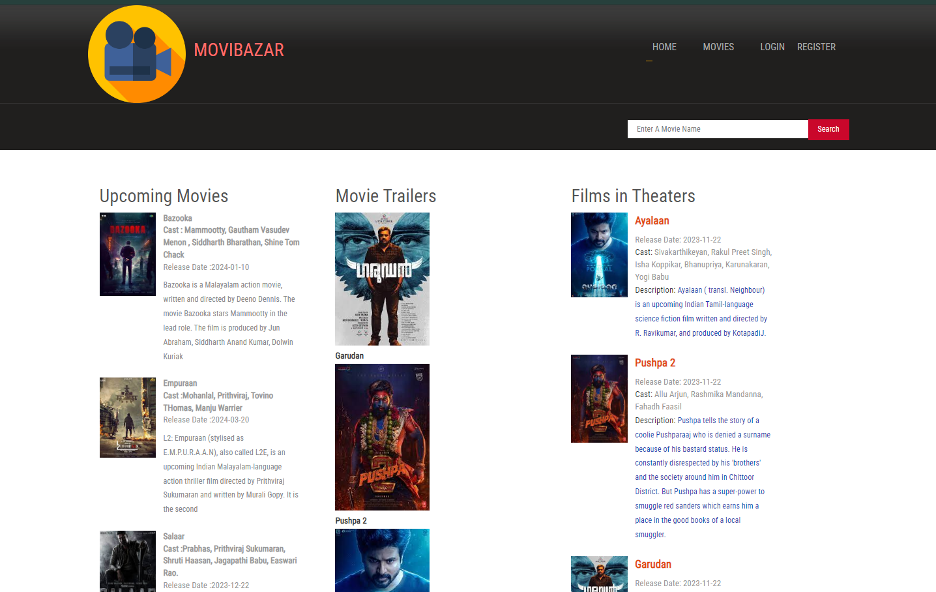

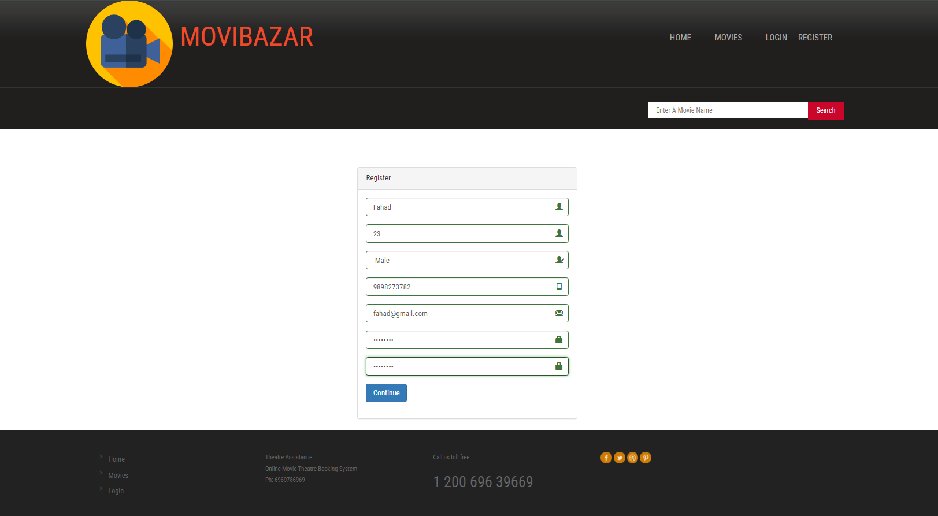

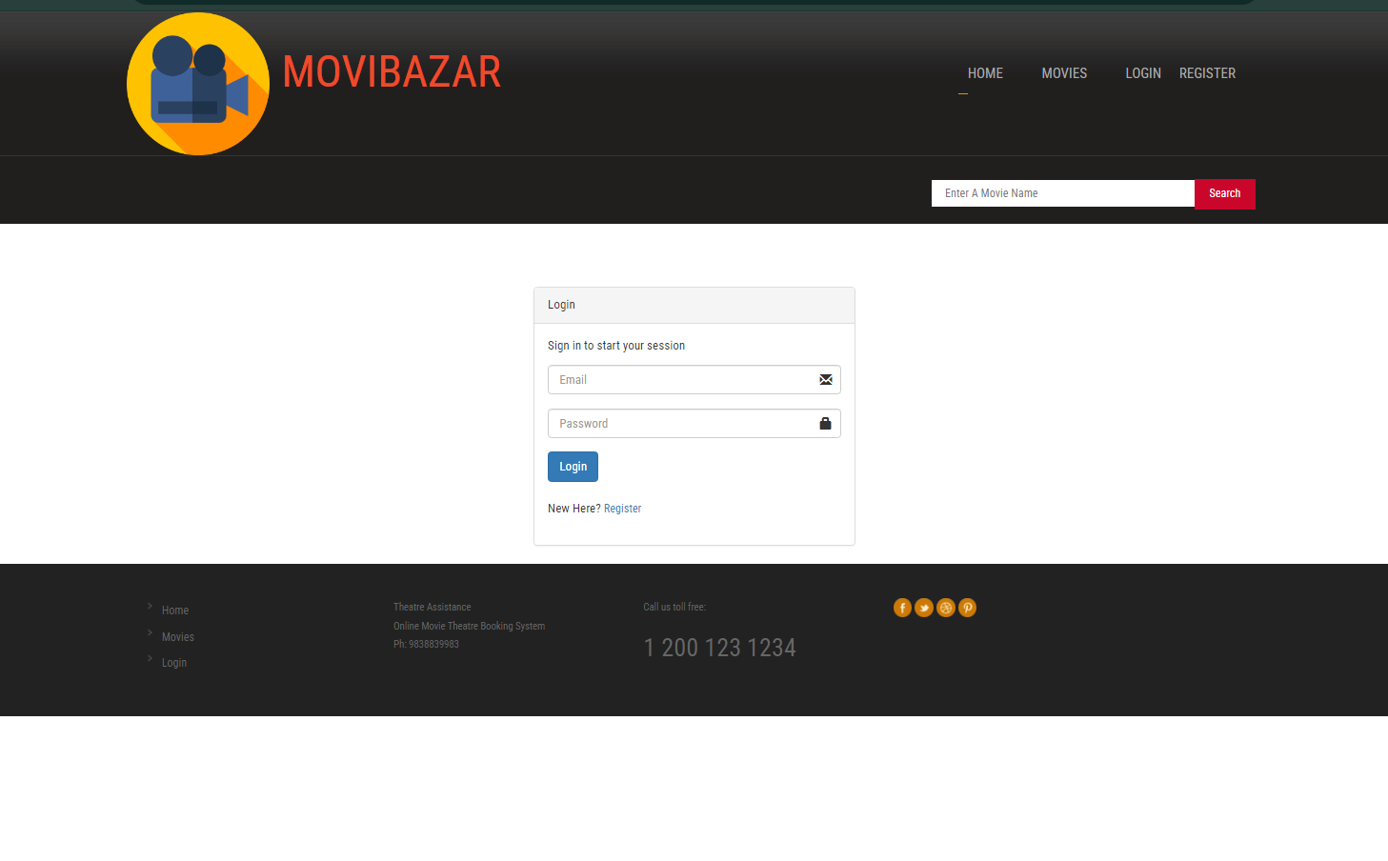

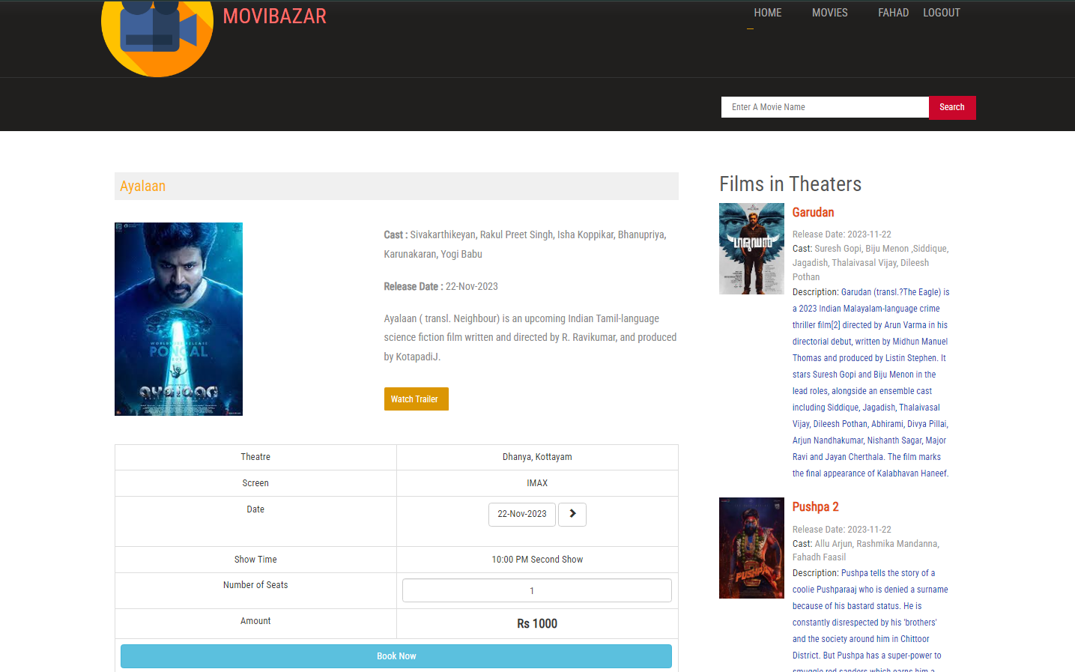

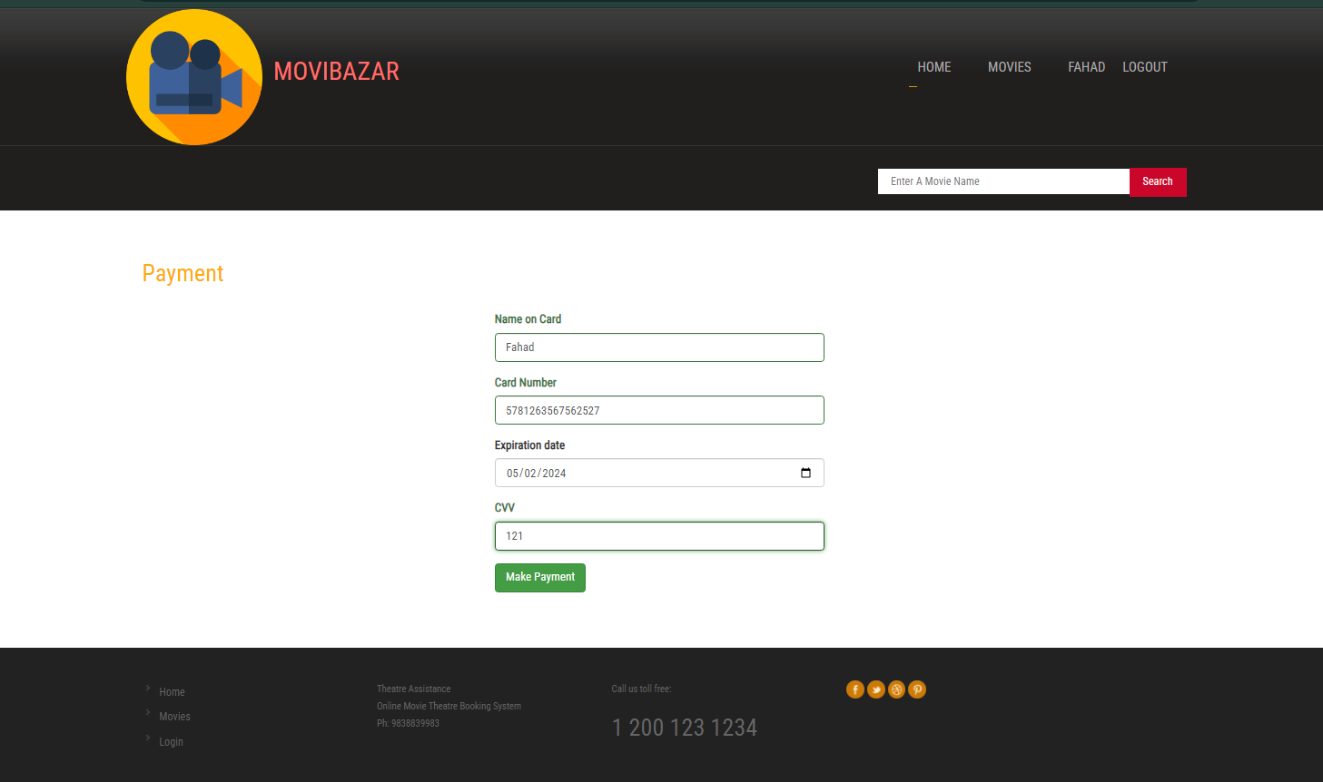

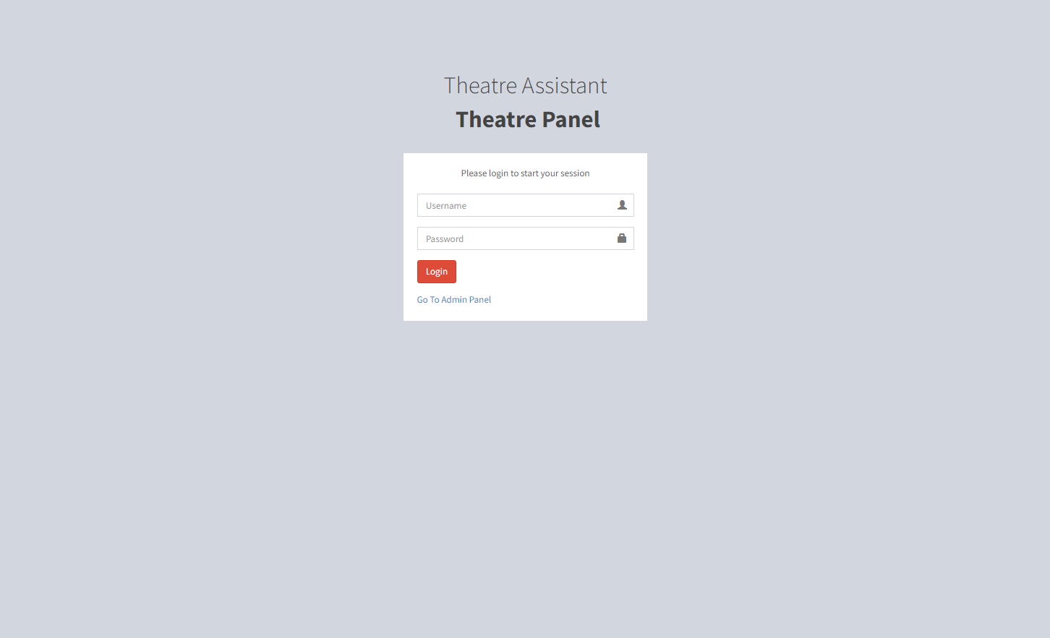

# 

# 

# 

# 

# 

# 

# 

# 

# 

# SOURCE CODE

# <html>

# <body>

# <?php

# include('header.php');

# ?>

# <div class="content">

# <div class="wrap">

# <div class="content-top">

# <div class="listview_1_of_3 images_1_of_3">

# <h2 style="color:#555;">Upcoming Movies</h2>

# <?php

# $qry3=mysqli_query($con,"SELECT * FROM tbl_news LIMIT 5");

# 

# while($n=mysqli_fetch_array($qry3))

# {

# ?>

# <div class="content-left">

# <div class="listimg listimg_1_of_2">

# <img src="admin/<?php echo $n['attachment'];?>">

# </div>

# <div class="text list_1_of_2">

# <div class="extra-wrap">

# <span style="text-color:#000" class="data"><strong><?php echo $n['name'];?></strong><br>

# <span style="text-color:#000" class="data"><strong>Cast :<?php echo $n['cast'];?></strong><br>

# <div class="data">Release Date :<?php echo $n['news_date'];?></div>

# 

# 

# 

# <span class="text-top"><?php echo $n['description'];?></span>

# </div>

# </div>

# <div class="clear"></div>

# </div>

# <?php

# }

# ?>

# 

# 

# </div>

# <div class="listview_1_of_3 images_1_of_3">

# <h2 style="color:#555;">Movie Trailers</h2>

# <div class="middle-list">

# <?php

# $qry4=mysqli_query($con,"SELECT * FROM tbl_movie ORDER BY rand() LIMIT 6");

# 

# while($nm=mysqli_fetch_array($qry4))

# {

# ?>

# 

# <div class="listimg1">

# <a target="_blank" href="<?php echo $nm['video_url'];?>"><img src="<?php echo $nm['image'];?>" alt=""/></a>

# <a target="_blank" href="<?php echo $nm['video_url'];?>" class="link" style="text-decoration:none; font-size:14px;"><?php echo $nm['movie_name'];?></a>

# </div>

# <?php

# }

# ?>

# </div>

# 

# 

# </div>

# <?php include('movie_sidebar.php');?>

# </div>

# </div>

# <?php include('footer.php');?>

# </div>

# <?php include('searchbar.php');?>

# <?php include('header.php');

# if(!isset($_SESSION['user']))

# {

# header('location:login.php');

# }

# $qry2=mysqli_query($con,"select * from tbl_movie where movie_id='".$_SESSION['movie']."'");

# $movie=mysqli_fetch_array($qry2);

# ?>

# <div class="content">

# <div class="wrap">

# <div class="content-top">

# <div class="section group">

# <div class="about span_1_of_2">

# <h3 style="color:black;" class="text-center">BOOKING HISTORY</h3>

# <?php include('msgbox.php');?>

# <?php

# $bk=mysqli_query($con,"select * from tbl_bookings where user_id='".$_SESSION['user']."'");

# if(mysqli_num_rows($bk))

# {

# ?>

# <table class="table table-bordered">

# <thead>

# <th>Booking Id</th>

# <th>Movie</th>

# <th>Theatre</th>

# <th>Screen</th>

# <th>Show</th>

# <th>Seats</th>

# <th>Amount</th>

# <th></th>

# </thead>

# <tbody>

# <?php

# while($bkg=mysqli_fetch_array($bk))

# {

# $m=mysqli_query($con,"select * from tbl_movie where movie_id=(select movie_id from tbl_shows where s_id='".$bkg['show_id']."')");

# $mov=mysqli_fetch_array($m);

# $s=mysqli_query($con,"select * from tbl_screens where screen_id='".$bkg['screen_id']."'");

# $srn=mysqli_fetch_array($s);

# $tt=mysqli_query($con,"select * from tbl_theatre where id='".$bkg['t_id']."'");

# $thr=mysqli_fetch_array($tt);

# $st=mysqli_query($con,"select * from tbl_show_time where st_id=(select st_id from tbl_shows where s_id='".$bkg['show_id']."')");

# $stm=mysqli_fetch_array($st);

# ?>

# <tr>

# <td>

# <?php echo $bkg['ticket_id'];?>

# </td>

# <td>

# <?php echo $mov['movie_name'];?>

# </td>

# <td>

# <?php echo $thr['name'];?>

# </td>

# <td>

# <?php echo $srn['screen_name'];?>

# </td>

# <td>

# <?php echo $stm['name'];?>

# </td>

# <td>

# <?php echo $bkg['no_seats'];?>

# </td>

# <td>

# Rs. <?php echo $bkg['amount'];?>

# </td>

# <td>

# <?php if($bkg['ticket_date']<date('Y-m-d'))

# {

# ?>

# <i class="glyphicon glyphicon-ok"></i>

# <?php

# }

# else

# {?>

# <a href="cancel.php?id=<?php echo $bkg['book_id'];?>" style="text-decoration:none; color:red;">Cancel</a>

# <?php

# }

# ?>

# </td>

# </tr>

# <?php

# }

# ?></tbody>

# </table>

# <?php

# }

# else

# {

# ?>

# <h3 style="color:red;" class="text-center">No Previous Bookings Found!</h3>

# <p>Once you start booking movie tickets with this account, you'll be able to see all the booking history.</p>

# <?php

# }

# ?>

# </div>

# <?php include('movie_sidebar.php');?>

# 

# </div>

# <div class="clear"></div>

# </div>

# </div>

# </div>

# <?php include('footer.php');?>

# <script type="text/javascript">

# $('#seats').change(function(){

# var charge=<?php echo $screen['charge'];?>;

# amount=charge*$(this).val();

# $('#amount').html("Rs "+amount);

# $('#hm').val(amount);

# });

# </script>

# <?php include('header.php');?>

# </div>

# <div class="content">

# <div class="wrap">

# <div class="content-top">

# <center><h1 style="color:#555;">(NOW SHOWING)</h1></center>

# 

# <?php

# $today=date("Y-m-d");

# $qry2=mysqli_query($con,"select * from tbl_movie ");

# 

# while($m=mysqli_fetch_array($qry2))

# {

# ?>

# 

# <div class="col_1_of_4 span_1_of_4">

# <div class="imageRow">

# <div class="single">

# <?php

# 

# ?>

# <a href="about.php?id=<?php echo $m['movie_id'];?>"><img src="<?php echo $m['image'];?>" alt="" /></a>

# </div>

# <div class="movie-text">

# <h4 class="h-text"><a href="about.php?id=<?php echo $m['movie_id'];?>" style="text-decoration:none;"><?php echo $m['movie_name'];?></a></h4>

# Cast: <Span class="color2" style="text-decoration:none;"><?php echo $m['cast'];?></span><br>

# 

# </div>

# </div>

# </div>

# 

# <?php

# }

# ?>

# 

# </div>

# <div class="clear"></div>

# </div>

# <?php include('footer.php');?>